

**Provision of Minor Injury Unit Services**

**Briefing Document**

**Introduction**

This document has been produced to:

* Provide information about minor injury unit services within the Health Board
* Advise of recent issues experienced by the service
* Set out proposals for adjustments in the operating hours of some of these services in the future.

It is important that everyone who has an interest in minor injury unit services has an opportunity to understand the proposals and to let us know their views.

**Background**

Aneurin Bevan University Health Board is responsible for all health services across the former county of Gwent (including the local authority areas of Newport, Caerphilly, Monmouth, Torfaen and Blaenau Gwent) and some of the population of south Powys.

The Health Board maintains a number of Minor Injury Units (MIUs) which are part of the overall urgent care service. MIUs are nurse-led units which treat injuries that are not life nor limb-threatening. They are part of an overall model of care whereby the Grange University Hospital (GUH) near Cwmbran delivers emergency treatment and the enhanced local general hospital (eLGH) network delivers minor injury services.

The MIU service is led and delivered by specialist-trained Emergency Nurse Practitioners (ENPs), who are able to work independently and treat a range of injuries in both adults and paediatrics at each MIU site.

**Operation of the Service**

The Health Board currently provides the MIU service across its three eLGHs and one community hospital as follows:

|  |  |
| --- | --- |
| **Royal Gwent Hospital (RGH)** | Open 24 hours, seven days per week |
| **Nevill Hall Hospital**  **(NHH)** | Open 24 hours, seven days per week |
| **Ysbyty Ystrad Fawr**  **(YYF)** | Open 18 hours from 7.00am to 1.00am, seven days per week  (reduced from 24/7 during the COVID pandemic) |
| **Ysbyty Aneurin Bevan (YAB)** | Open 10 hours from 9.00am to 7.00pm, Monday to Friday  (excluding bank holidays) |

The MIUs receive approximately 50% of all urgent and emergency care patients across the Health Board.

**Recent Issues Affecting the Service**

Two key issues are currently affecting the minor injuries service as follows:

Patterns of demand for the service

The following chart shows daily attendances at each MIU site from 1 April 2022 to 14 August 2023:

* RGH MIU sees between 75 and 140 patients per day (or four patients per hour based on a 24/7 service)
* YYF MIU sees between 51 and 90 patients per day (or three patients per hour based on a daily service from 07:00 to 01:00)
* NHH MIU sees between 36 and 68 patients per day (or two patients per hour based on a 24/7 service)
* YAB MIU sees between 18 and 50 patients per day (or two patients per hour based on a weekday service from 09:00 to 19:00).

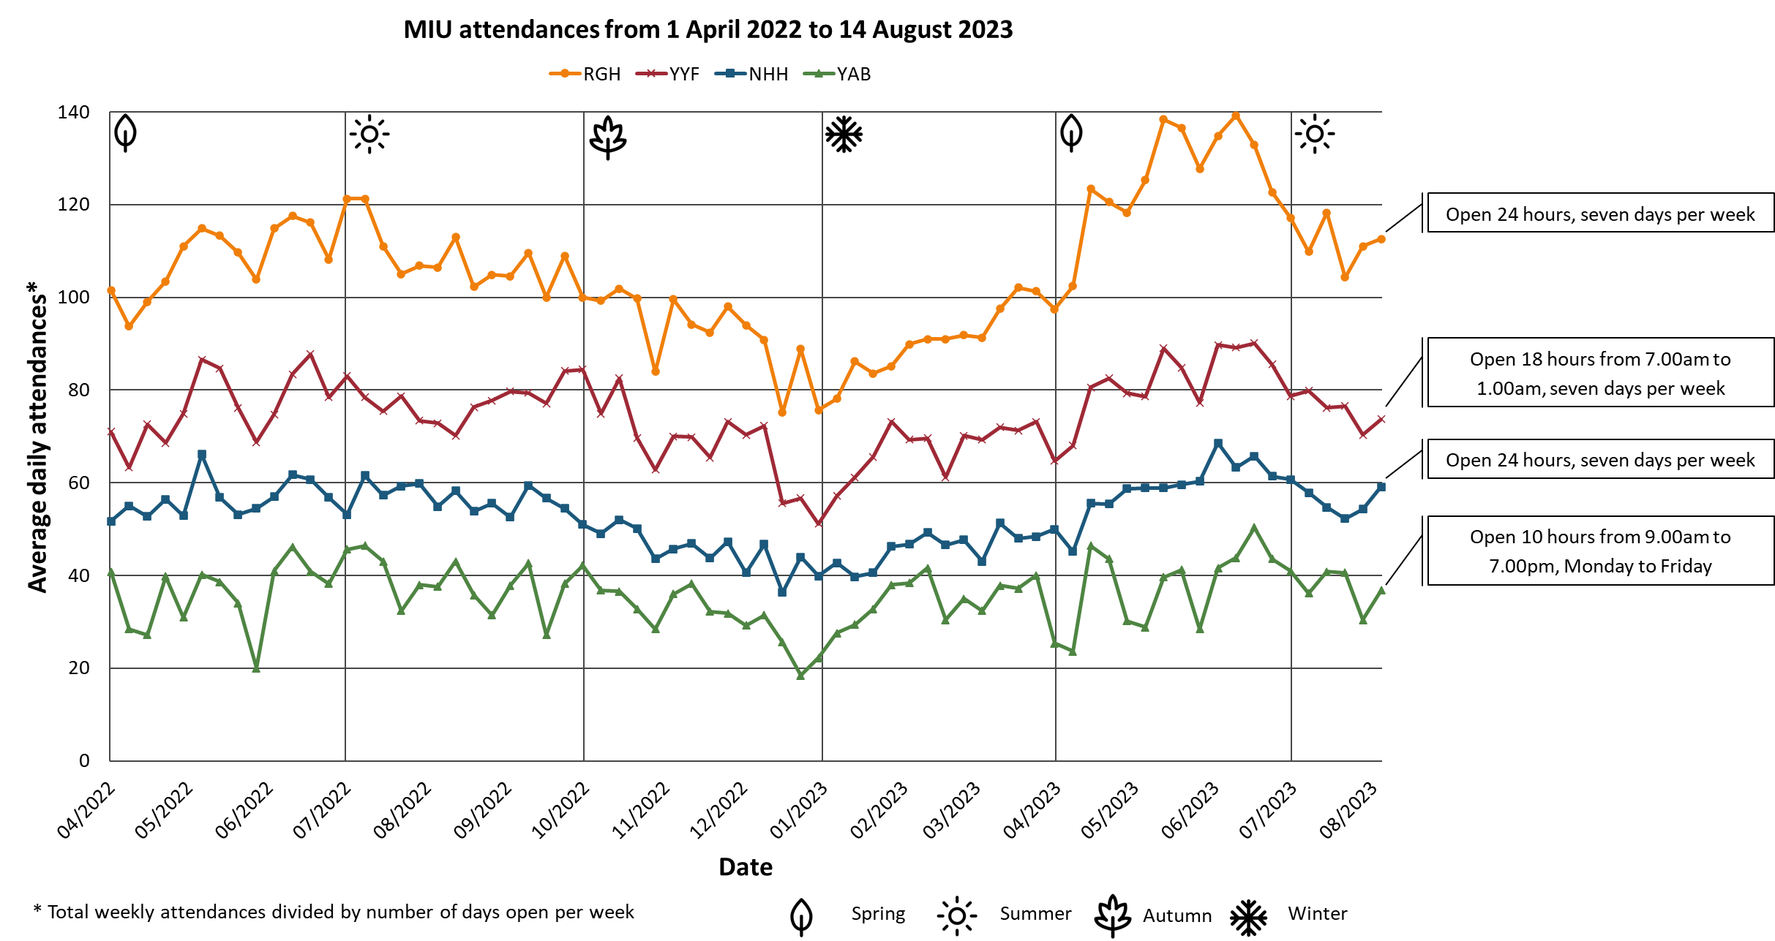

A recent evaluation of MIU demand has identified key patterns of activity across all sites, including:

* Seasonal patterns of activity, with an early summer peak at each site
* Daily patterns of activity, with a Monday peak at each site
* Hourly patterns of activity, with a mid-morning peak and gradually decreasing demand until closure hours or around midnight at each site.

This exercise highlighted a significant imbalance between opening hours and patient demand across the MIUs. For example, very few patients attend NHH MIU between 1.00am and 7.00am. Between 1 April 2022 and 31 March 2023, there were 400 attendances to NHH MIU (approximately one patient per night) during these hours. By contrast, there were 1,530 attendances to RGH MIU (approximately four patients per night) during the same hours.

Workforce utilisation

The Health Board values its highly-skilled ENP workforce. In recognition of the very low overnight patient demand at NHH MIU, it is important to ensure that this valuable resource is used as effectively as possible.

**Planning for the Future Service**

In response to the above findings, the Health Board has considered a number of options for future service provision. The aim has been to ensure optimal matching of capacity to demand and develop the most robust and sustainable model for the future.

The preferred option is to make permanent the current temporary arrangements at YYF (open 7.00am to 1.00am, seven days per week) and to introduce the same opening hours pattern at NHH. If adopted, service provision would be as set out below:

|  |  |
| --- | --- |
| **RGH** | Open 24 hours, seven days per week |
| **NHH** | Open 18 hours every day from 7.00am to 1.00am seven days per week |
| **YYF** | Open 18 hours every day from 7.00am to 1.00am seven days per week |
| **YAB** | Open from 9.00am to 7.00pm Monday to Friday  (excluding bank holidays) |

Services would remain on all the existing sites with a 24-hour MIU at RGH. This option is considered to provide the most effective, efficient and sustainable service model for our MIUs by matching service hours with patient usage.

**Seeking the Views of the Public**

Before a final decision is made, the Health Board wishes to engage with service users, staff, supporting services, voluntary groups and all other stakeholders. It is important that all those with an interest in the service have the opportunity to:

* Understand the proposals
* Provide full feedback
* Raise any queries or concerns for response.

Your views will provide valuable information to inform final decisions and service details, and to ensure that any impact on users is assessed and minimised.

**How will the Health Board do this?**

In order to ensure that everyone has the opportunity to make their views known, the Health Board is initiating an eight-week period of engagement, involving the following:

* Prominent display of information in service areas, to include posters and displays
* Information / survey forms provided for people attending MIUs
* Dedicated information page on Health Board website, to include frequently asked questions, access to patient surveys (with the option of paper versions), contact points and updated as plans progress
* Face to face public information sessions / engagement events
* Social media messaging
* Presentations to stakeholders
* Management meetings for internal NHS stakeholders
* Work with health inclusion team.

It is planned that the engagement period will run from **9.00am on Monday 11 September 2023 until 5.00pm on Friday 3 November 2023**

**How can people make their views known?**

Views can be shared by any of the following means:

* Complete our survey which can be accessed via the Health Board web site URL or via the QR code below

**URL:** [**https://bit.ly/45U1CAS**](https://bit.ly/45U1CAS)

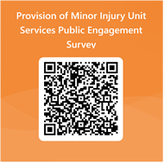

* Attend a public engagement session, where you can find out more about the proposal and ask any questions of Health Board / MIU staff. These have been arranged as follows:

|  |  |
| --- | --- |
| **Mon 18th September**  **5.30pm – 7.30pm** | **Nevill Hall Hospital**  **Abergavenny**  **(Minor Injury Unit)** |
| **Wed 20th September**  **2.00pm – 4.00pm** | **The Old Library Community Café, Caerphilly** |
| **Wed 27th September**  **5.30pm - 7.00pm** | **On-line via**  **Microsoft Teams** |
| **Fri 29th September**  **10.00am – 12.00noon** | **Abergavenny Market** |
| **Mon 2nd October**  **2.00pm – 3.30pm** | **On-line via**  **Microsoft Teams** |
| **Tue 3rd October**  **5.30pm – 7.30pm** | **Ysbyty Ystrad Fawr**  **Ystrad Mynach**  **(First Floor Lift Lobby)** |

* Contact us by e-mail with any comments (or if you would like to join one of the on-line sessions above) at [**abb.engagement@wales.nhs.uk**](mailto:abb.engagement@wales.nhs.uk)
* Contribute to any conversations via the Health Board’s social media channels e.g. **Facebook or X (previously Twitter).**

**What will happen after the engagement period?**

All responses and views will be collated and an engagement report prepared. This report will be shared with the Llais Gwent Region (the body that has replaced Community Health Councils) to identify: whether a final decision can be made on future minor injury service provision; or whether further actions are required.

Subject to further discussions with Llais, we may wish to enter a period of formal consultation. Should we enter formal consultation, we will once again invite your views.